This section defines how developers interact with NEXUS from the terminal and how the CLI communicates with the backend. The aim is to make the system predictable for users and straightforward for three developers to implement and test independently.
The API is the contract between components. The CLI should not need to know how PostgreSQL stores a task, which local model generates a plan, or how the Windows bridge searches files.

03.16.1 Design objectives
- Keep the CLI terminal-first, concise and useful for everyday tasks.
- Use versioned API routes so changes can be introduced safely.
- Return durable task identifiers and clear lifecycle states.
- Support task creation, progress checks, approval, cancellation and history.
- Return consistent machine-readable errors.
- Enforce authentication and authorization in the backend, not in the CLI.
- Keep bridge communication separate from the public user-facing API.
- Make requests safe to retry when the client loses a response.

03.16.2 Logical communication flow
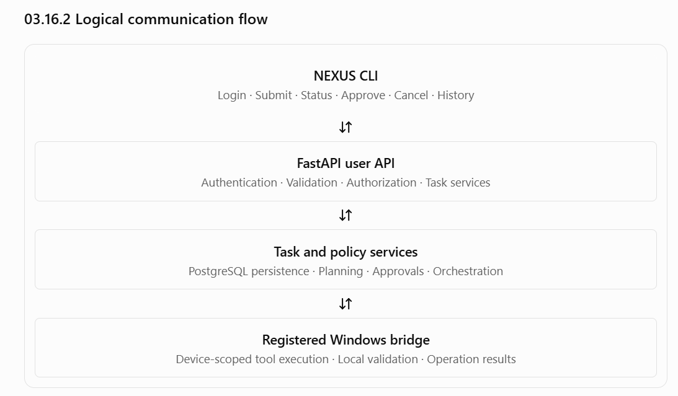

The diagram shows the logical relationship. The final bridge communication direction—polling or persistent connection—remains a separate deployment decision. The CLI must never contact the bridge directly to bypass backend policy.

03.16.03 API conventions
Proposed conventions:
- Base path: /v1
- Data format: JSON for request and response bodies.
- Authentication: bearer access token, subject to the final authentication design.
- Task IDs, device IDs and operation IDs: opaque identifiers; clients must not construct meaning from their internal format.
- Timestamps: UTC ISO 8601 values.
- List responses: bounded and paginated where needed.
- Validation failures: consistent error structures.
- API changes: additive changes where possible; breaking changes require a versioning decision.
These are proposed contract conventions, not an implementation already completed.

Common error structure
{
"error": {
"code": "TASK_NOT_FOUND",
"message": "The requested task was not found.",
"request_id": "request-correlation-id",
"retryable": false
}
}
The exact fields can be adjusted during implementation, but the contract should consistently provide a stable error code, a human-readable explanation and a correlation identifier. Additional details must not expose secrets, internal stack traces or another user's data.
The backend should use appropriate HTTP status codes—for example, validation errors, authentication failures, authorization failures, missing resources, conflicting state and rate limiting—rather than returning HTTP success for every outcome.

03.16.04 Proposed API endpoint catalogue
The following endpoints form the proposed MVP contract. Exact names and schemas should be frozen before the CLI and backend are implemented in parallel.
Method | Endpoint | Purpose
POST | /v1/auth/login | Authenticate a user
POST | /v1/auth/refresh | Obtain a refreshed access token, if refresh tokens are adopted
POST | /v1/auth/logout | End or revoke the current session
GET | /v1/me | Return the authenticated user's profile
GET | /v1/devices | List devices the user is authorized to access
GET | /v1/devices/{device_id} | Retrieve a device's registration and health status
POST | /v1/tasks | Submit a task
GET | /v1/tasks | List the user's authorized task history
GET | /v1/tasks/{task_id} | Retrieve task status and summary
GET | /v1/tasks/{task_id}/steps | Retrieve step-level progress
GET | /v1/tasks/{task_id}/result | Retrieve the available task result
POST | /v1/tasks/{task_id}/cancel | Request task cancellation
POST | /v1/tasks/{task_id}/approvals/{approval_id} | Submit an approval or rejection decision
GET | /v1/memories | List the user's authorized memories
POST | /v1/memories | Create a memory
GET | /v1/memories/{memory_id} | Inspect a memory
PATCH | /v1/memories/{memory_id} | Update a memory
DELETE | /v1/memories/{memory_id} | Request deletion of a memory
Some endpoints depend on decisions that remain open. For example, the refresh endpoint is conditional on the final session design, and memory endpoints depend on the memory-management scope agreed in Section 03.14.
The Windows bridge should use a separately defined device-facing contract. It must not reuse user endpoints as an unrestricted execution channel.

03.16.05 Task submission contract

Request
Proposed POST /v1/tasks body:
{
"client_request_id": "client-generated-unique-id",
"target_device_id": "registered-device-id",
"request": "Find the design documents in my project folder"
}
Field requirements:
- client_request_id: generated by the CLI before submission and reused when retrying the same submission.
- target_device_id: an explicitly selected, registered device. The backend must verify that the user is authorized to target it.
- request: the user's natural-language task, subject to documented size limits.
The client must not supply authoritative fields such as task ownership, approval status, risk tier, worker claim or final task status. Those are controlled by the backend.

Accepted response
A successful submission should return a task identifier and current state, for example:
{
"task_id": "task-id",
"status": "queued",
"created_at": "2026-10-22T12:30:00Z",
"status_url": "/v1/tasks/task-id"
}
This example illustrates the contract shape, not a committed timestamp or exact final schema.
Meaning of acceptance: the backend has durably accepted the request. It does not mean the plan is valid, approval has been granted, or the computer task has completed.
If the client times out after submission, it should retry using the same client_request_id and equivalent request. The backend must return the existing task where the idempotency contract applies, instead of creating another task.

03.16.06 Task status and progress

Task status response
GET /v1/tasks/{task_id} should return a task summary containing:
- Task ID and current state.
- Target device ID.
- Creation and last-update timestamps.
- Current step or progress summary, when available.
- Whether user action is required.
- Error classification, if applicable.
- Outcome summary, if terminal.
A possible response:
{
"task_id": "task-id",
"status": "running",
"target_device_id": "registered-device-id",
"created_at": "2026-10-22T12:30:00Z",
"updated_at": "2026-10-22T12:30:08Z",
"progress": {
"completed_steps": 1,
"total_steps": 3
},
"action_required": false
}
Progress counters must reflect persisted step data. They should not imply an exact percentage of completion if the system cannot estimate the remaining work reliably.

Step response
GET /v1/tasks/{task_id}/steps should expose ordered step summaries, including:
- Step ID and sequence number.
- Registered tool name.
- Step state.
- Attempt count.
- Start and completion times where available.
- Safe result summary or structured error.
- Whether approval or recovery is required.
Arguments and outputs may contain private paths, document content or other sensitive information. The endpoint must apply authorization and response filtering rather than exposing every internal field by default.

Polling behavior
For the initial CLI, polling is sufficient:
- Submit the task.
- Display its task ID.
- Poll status with a configurable interval.
- Display state changes and newly available progress.
- Stop polling when a terminal state is reached or the user chooses to stop waiting.
Stopping the CLI's wait loop must not cancel the backend task. Cancellation must be an explicit operation.
Server-Sent Events or WebSockets can be evaluated later if polling becomes inefficient or noticeably harms the user experience.

03.16.07 Approval contract
When a task needs approval, NEXUS must expose the pending decision and enough information for the user to understand the operation.
A pending approval should identify:
- Approval ID.
- Task and step IDs.
- Target device.
- Tool and proposed operation.
- Relevant parameters and affected resource.
- Reason approval is required.
- Expiry time, if configured.
- Current approval status.
The approval request must not display only a vague message such as “Allow AI to continue?” It should describe the actual operation.
Proposed decision body:
{
"decision": "approve",
"decision_request_id": "unique-decision-request-id"
}
The allowed decision values, replay behavior and idempotency rules must be finalized in the contract.
The backend must independently verify ownership, the current task and approval states, expiry, operation fingerprint and authorization. A CLI-supplied approval is only a user decision request; it does not override the policy engine.
If the operation changes after the approval was presented, the old approval must not authorize the modified operation.

03.16.08 Cancellation contract
Proposed endpoint:
POST /v1/tasks/{task_id}/cancel
The response should distinguish the cancellation request from the final task outcome. For example:
{
"task_id": "task-id",
"status": "cancellation_requested",
"message": "Cancellation was requested; the final outcome is not yet confirmed."
}
cancellation_requested here is a response-level indication, not necessarily a new durable task state. The durable state machine should use the explicitly agreed state model.
The client should then retrieve task status until the outcome is known, or stop waiting and leave the task available for later inspection.
The API must not promise that a completed file write, launched application or other external effect has been undone.

03.16.09 Task history and result contract
The history endpoint should support filtering by status and target device, with bounded pagination. It must enforce the authenticated user's access rules.
A list response should include a page of task summaries and pagination information. It should not return full document contents or large step outputs by default.
The task result endpoint should distinguish:
- Successful completion with verified outcome.
- Partial success.
- Definite failure.
- Cancellation with any completed actions preserved.
- An unresolved or uncertain outcome requiring recovery.
A final result should include completed steps, failed steps, skipped steps and uncertain steps as applicable. Each result should provide a stable error code when relevant and a clear human-readable explanation.
A result is not considered successful merely because the AI produced a plausible summary. It must be grounded in recorded operation results and the applicable verification contract.

03.16.10 CLI command design
The CLI is the main user experience for the MVP. It should support both concise interactive use and explicit subcommands suitable for scripts.
The proposed command vocabulary is:
Command | Purpose
nexus login | Authenticate the user
nexus logout | End the local session
nexus devices | List accessible registered devices
nexus status | Show backend and relevant device connectivity
nexus run | Submit a natural-language task
nexus task <task-id> | Inspect task status
nexus task <task-id> --watch | Wait for progress updates
nexus task <task-id> --steps | Inspect step-level details
nexus task <task-id> --result | Display the result
nexus cancel <task-id> | Request cancellation
nexus approve <task-id> <approval-id> | Submit a decision for a pending approval
nexus reject <task-id> <approval-id> | Reject a pending approval
nexus history | View recent authorized tasks
nexus memory list | List saved memories
nexus memory show <memory-id> | Inspect a memory
nexus memory delete <memory-id> | Request memory deletion
These names are a proposed CLI interface, not final command-line syntax. The implementation should settle option names, aliases, output formats and exit codes before the CLI/backend integration milestone.

Target device selection
A task must have an explicit target device.
The CLI may offer a convenient configured default, but it should display which device is selected and allow the user to override it. If the selected device is offline, NEXUS should report that condition rather than silently using another computer.

Interactive and machine-readable output
Provide two output modes:
- Human mode: concise messages, progress updates, approval prompts and readable summaries.
- Machine mode: stable JSON output suitable for shell scripts and automated testing.
For example:
nexus devices
nexus run --device my-laptop "Find the project design documents"
nexus task <task-id> --watch
nexus task <task-id> --result
These commands are illustrative. Exact argument names and the mechanism for selecting a device alias remain to be decided.
For machine mode, output should avoid mixing progress banners or decorative terminal text into JSON on standard output. Diagnostics can go to standard error.

03.16.11 Example user interaction
A normal task should feel predictable, not like a stream of opaque model activity.
USER
nexus run --device my-laptop "Find the design documents in my project folder"
NEXUS
Task accepted: task-123
Target device: my-laptop
Status: queued
PROGRESS
Status: running
Step 1: Searching the permitted project directory.
Step 2: Waiting for search results.
RESULT
Task completed.
Found 4 matching files. The result includes file names and permitted paths.
If the operation needs approval, the CLI should pause the affected execution path and show the specific operation and relevant parameters. It must not pretend that a step is running while waiting for a user decision.

03.16.12 CLI error and exit-code conventions
The CLI should present errors consistently and preserve machine-readable details for scripts.
Situation | User-facing behavior
Not authenticated | Explain that login is required
Invalid request | Identify the invalid input without exposing internal stack traces
Target device offline | State which device is unavailable; do not reroute silently
Task still running | Display current state; keep waiting only when requested
Approval required | Show the pending operation and the decision command
Cancellation pending | State that cancellation was requested but is not confirmed
Uncertain operation | Explain that the outcome cannot yet be established
Permission denied | Explain the denied action at an appropriate level of detail
Backend unavailable | Explain that the request could not be completed or confirmed
Exit codes should be documented and stable. The CLI must distinguish a successful task from an accepted-but-still-running task and from a command that failed. The exact numeric assignments remain open.

03.16.13 API security and validation
All user-facing endpoints must:
- Authenticate requests except for explicitly public bootstrap or login routes.
- Authorize access to the specific task, device, approval or memory.
- Validate path parameters, query parameters and request bodies.
- Apply documented request-size and pagination limits.
- Reject malformed identifiers and invalid state transitions.
- Avoid exposing whether another user's private resource exists when that distinction would leak information.
- Use rate limits for sensitive operations such as login and repeated approval attempts.
- Avoid placing credentials or sensitive task content in URLs.
- Record relevant security events without logging secrets.
The backend must treat the CLI as an untrusted client. A modified CLI must not be able to bypass approval checks by calling an endpoint directly.

03.16.14 API contract testing
Before the components are integrated, the team should agree on schemas and create contract tests.
- Task submission validates required fields.
- Retrying a submission with the same request ID returns the existing task.
- Reusing an identifier with conflicting content returns a conflict.
- Users cannot inspect other users' tasks, steps, results or memories.
- An approval cannot authorize a modified operation.
- A cancellation response does not falsely claim completed cancellation.
- Pagination and filtering enforce ownership and bounded response sizes.
- Machine-readable output is valid JSON without terminal decoration.
- Errors include stable codes and appropriate HTTP status codes.
- CLI and backend agree on field names, enum values and state meanings.
- API changes are tested against the existing contract suite.
The API schema should become a shared team artifact. One developer should not independently invent request fields while another builds the CLI around different assumptions.

03.16.15 Decisions still open
Before implementation, the team needs to settle the following:
- Authentication: local password accounts, session/refresh-token lifecycle and secure credential storage.
- Device selection: explicit device ID on every task versus a configured default with confirmation.
- Progress delivery: polling interval and whether the CLI needs a watch mode beyond basic polling.
- Approval UX: exact display format, expiry duration and confirmation behavior.
- History pagination: cursor-based or offset-based pagination.
- CLI framework: select a Python CLI library based on usability, maintainability and team familiarity.
- Output and exit codes: stable machine-readable JSON and documented exit-code meanings.
- Rate limits and request limits: values based on expected use and measured system capacity.
- API documentation: OpenAPI generated from FastAPI schemas, with contract tests and examples maintained alongside the implementation.

Section 03.16 exit criteria
This section is ready to move toward implementation when the three developers agree on the task submission contract, state representations, approval and cancellation behavior, error format, CLI command vocabulary, and shared API schema.

